CS2100 Homework Due Wednesday prior to class Name: Kurt Jensen

1, 2, 4 (3 is shown as a reference), 7 and 8. Submit as one PDF

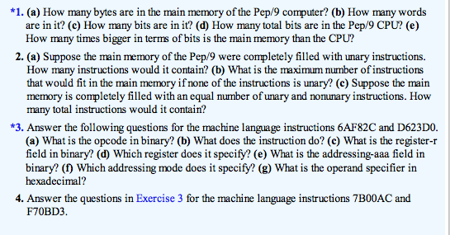

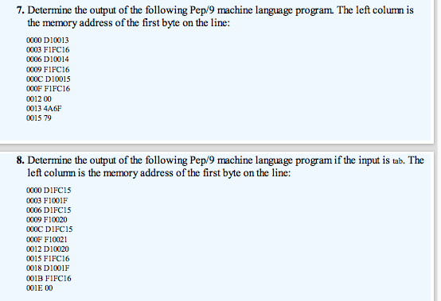

* 1. 65536 bytes
  2. 32768 words
  3. 524288
  4. 92 bits
  5. 5698.78261 times bigger

1. 1. 65536
   2. 21845.3333
   3. 32768 instructions
2. 1. 7B00AC
      1. 0111
      2. Subtracts from r
      3. 1
      4. Index register, X
      5. 011
      6. Stack-relative
      7. 00AC
   2. F70BD3
      1. 1111
      2. Store byte r to memory
      3. 0
      4. Accumulator, A
      5. 111
      6. Stack-deferred indexed
      7. 0BD3
3. 1. Joy
4. 1. at